Big Mountain Resort Capstone

By: Erika Adre

**Abstract**

Big Mountain Resort is looking for ways to monetize on their facilities or cut costs to increase revenue. Using the dataset provided and the US Population dataset from Wikipedia, we built a RandomForest model to find the features impacting ticket price for ski resorts and modeled four scenarios to either cut costs or increase revenue from ticket prices. Our model revealed that adding a run to increase the vertical drop by 150 ft and installing an additional chair lift would increase the support for ticket price by $8.61 and that closing down one run would not affect the support of the current ticket price.

**Introduction**

Big Mountain Resort added a chair lift that generates an additional operational cost of $1,540,000. Big Mountain would like to generate additional revenue to offset operational costs through cost cutting measures or monetizing on their facilities. Predicting how facilities impact ticket pricing for ski resorts are important for decisions on future investment and cost cutting measures. In this project, we are provided with ski_resort_data.csv that contains 330 rows. The rows are the different resorts in the United States with State and Region information. There were 24 features: Summit Elevation, Vertical Drop, Base Elevation, Trams, Fast Eight, Fast Six, Fast Quads, Quad, Triple, Double, Surface, Total Chairs, Runs, Terrain Parks, Longest Run (mi.), Skiable Terrain, Snow Making, Days Open Last Year, Years Open, Average Snowfall, Adult Weekday, Adult Weekend, Projected Days Open, Night Skiing

**Project Objective**

The goal of this project is to use data science to find out which features greatly impact ticket price, quantify how the addition or removal of features would impact the price, and present the best scenario to increase revenue.

**Exploratory Data Analysis**

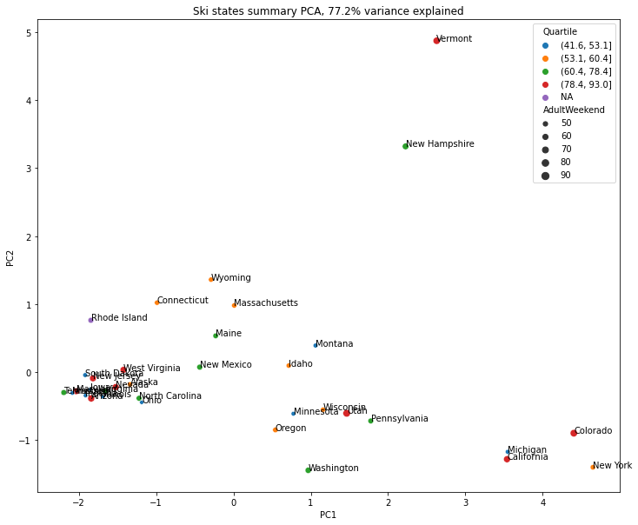

**Figure 1:** PCA Transformation was performed and showed that states can be treated equally due to no present grouping based on states

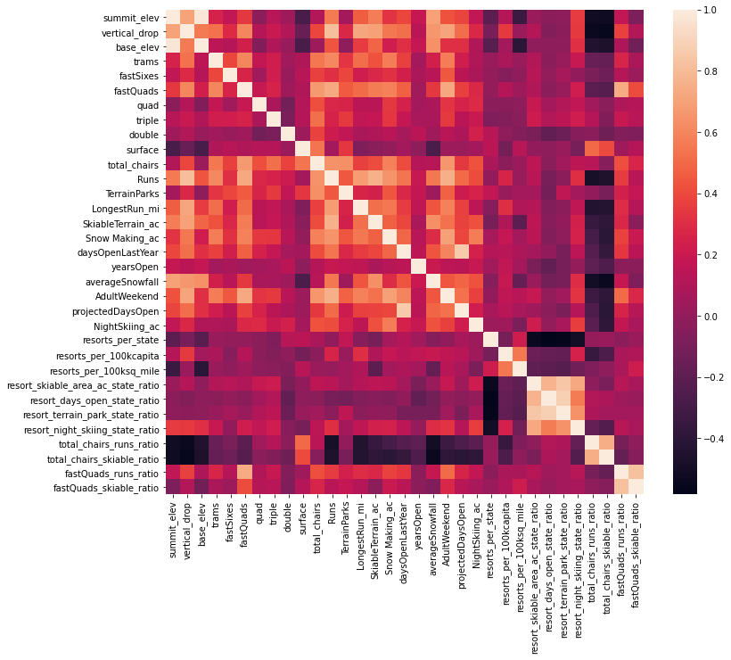

**Figure 2:** Heatmap to see a high level view of relationships amongst the features. It shows that the AdultWeekend ticket price is positively correlated with fastQuads, Runs, Snow Making_ac, Runs, vertical drop, and total_chairs. The resort_night_skiing_state_ratio is most correlated with ticket price.

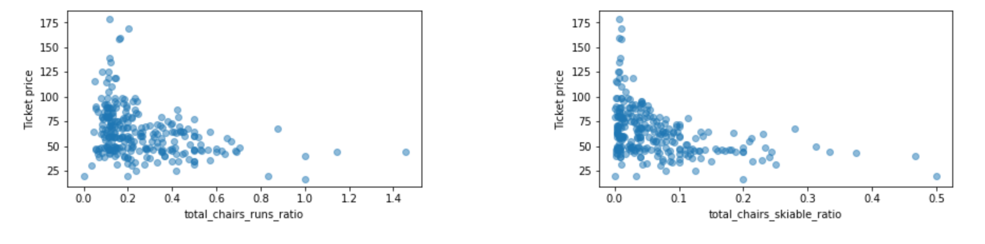

**Figure 3:** **(Left)** Ticket price vs total chairs : runs **(Right)** Ticket Price vs total chairs: skiable terrain shows us that increasing total chairs decreases ticket price. This shows that there is a supply/demand effect when it comes to total number of chairs. A higher price can be charged if the number of chairs is limited

**Model Selection**

We explored two different models: one that trains a linear regression model that scales the data, imputed missing values, and selects the k best features and the RandomForest model. We used GridSearchCV to find the best k value for the linear regression model and RandomForest’s number of trees.

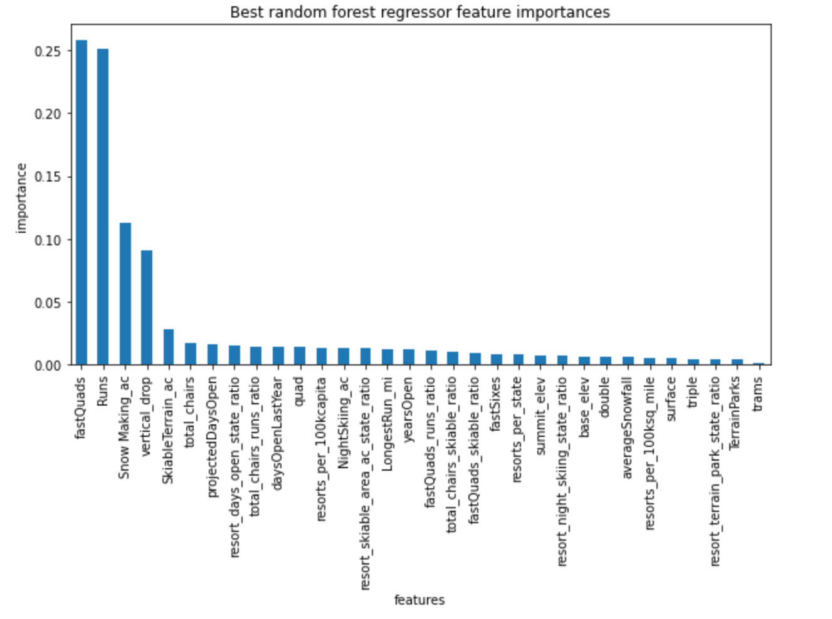

**Figure 4:** Random Forest model shows us that the fastQuads, Runs, Snow Making_ac, and vertical drops are the four most important features in pricing. This aggrees with the heat map from figure 2.

The model selected was the Random Forest Regression because it had a lower cross-validation mean absolute error of 9.6 compared to 10.5, and has a lower standard deviation for the mean absolute error of 1.3 compared to 1.6, showing that it has less variability.

**Prediction/Results**

Four Scenarios were explored:

1. Permanently closing down up to 10 of the least used runs
2. Increase vertical drop by 150 ft by adding a run and an additional chair lift.
3. Increasing vertical drop by 150ft by adding a run and additional chair lift with a snow making machine that adds 2 acres of coverage
4. Increase longest run by adding 0.2 miles and add a snow making machine to cover 4 acres.

Revenue calculations were made based on the assumption that there were 350,000 visitors for the season and each visitor got 5 day passes.

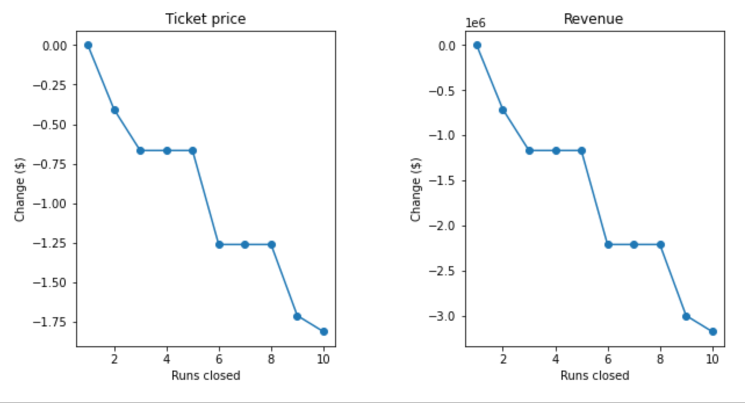

**Figure 5:** Changes in Price vs Number of Runs closed.

Figure 5 shows how closing a number of runs affects ticket pricing. Closing 1 run would not affect the price, but closing 2-3 runs would reduce support for ticket price, negatively affecting revenue. Closing down 4 or 5 runs would result in the same ticket price as closing down 3. Runs. Closing down 6 or more results in a significant decrease in ticket prices.

Adding a run and chair lift to increase the vertical drop by 150 ft results in a price increase of $8.61, resulting in a seasonal revenue of $15,065,471. Adding a snowmaking machine to scenario 2, only increases the ticket price to $9.90. There is a $1.29 difference between scenario 2 and 3. Adding the snow making machine makes little to no difference in ticket price. Scenario 4 results in no price increase.

**Conclusion**

A combination of scenario 1 and scenario 2 would be best to increase revenue for Big Mountain Resort. Cutting down 1 run would not decrease support for the ticket price while decreasing operation costs, while scenario 2 would increase the ticket price by 8.61.

For future improvements, knowing the operation and capital costs involved in adding features (adding runs, snow making, etc) would be useful in providing an accurate recommendation and cost analysis to management. This model was only based on revenue generated from adding the features based on the assumption that there were 350000 visitors for the season and they each bought 5 day tickets. This did not take into account the additional operation costs associsated with adding features in each scenario.